The Lazy Man's Guide To

Weight Loss

By Paul McDonald

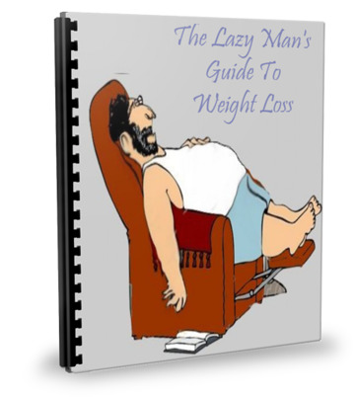

Preface

First and foremost, I would like to make it perfectly clear that I am not a weight loss guru, and I am not a doctor. This is a book from a guy who sits on his duff 10 to 14 hours per day making a living on the internet...which means that my time is spent in front of a computer screen all day. I found this method quite by accident, but it has changed my life in a spectacular way!

That being said, I would encourage you to check out anything and everything I say here with your doctor, (I think I have to say that, but it's true.) You may have conditions that cannot support what I am telling you here, so please make sure before you start this, (or any other diet program,) that it is safe for your particular body. There is nothing in here to my knowledge that would harm anyone, but by all means, let's be safe. I think I also need to include that results may not be typical. Our bodies are all different, so my results may not be your results. Okay...I think I've appeased my attorney.

My own doctor was concerned about my drastic weight loss, but when I told her what I was doing, she supported it 100%. My blood pressure and pulse rate were both very high, and I had no energy to speak of before I started this “diet.” I put that word in quotes, because it is NOT like a diet at all. In fact, my lifestyle hasn't changed much at all. I still sit on my fanny all of those hours, and yet, I am losing pounds...and not in small quantities. As a matter of fact, I have lost over 40 pounds in less than 3 months time, and I feel GREAT! That is why I am sharing this with you.

You have heard the phrase, “Stupid Simple,” I am sure. That is what this is. Stupid simple, and painless. That is MY kind of diet!

So...Let's Go!

In The Beginning
(Mindset is Everything)

To start off, you must understand that I am no spring chicken any more. At 58, my metabolism has slowed, as it does in folks who have matured. It is a natural thing, but it doesn't have to be that way....or at least to the extent that we have taught our bodies to react as we grow older. For many of us, it is an excuse. Laziness and inactivity creeps into our lives, so we must do something to combat that very thing.

Please keep in mind, that ANY weight loss regimen begins with you...and ONLY you. If you don't decide right now to change your habits...then you are doomed to fail. While this, once again, is stupid simple...ACTION is the key word here. Nobody can do this for you. You must decide that you are going to change your eating habits. You must decide if you want to be able to start breathing normally again, and start regaining the energy that you have lost. Just figuring that it is your age that is holding you back is only an excuse.

If you tell yourself that you will not be able to do this, then guess what...you won't. You have to start with a positive mindset, and knowing that your are doing something that is life changing. I have to tell you...being free from my blood pressure medication was a HUGE thing for me. Being able to once again play basketball with my four newly adopted children was not only life changing for me...but for them as well. It has also been nice to be able to reach down and do something as small as tie my own shoelaces without getting winded. My pants fit again, and my belly doesn't hang over my belt the way it use to. All of this has given me a new outlook on life, and yes, a new beginning.

Do not sell yourself short. You CAN do this! Believe in yourself, and have faith! You are choosing to do the right thing for your body. I am not going to go any further into it, because you have probably already heard it all before. You have probably already beat yourself up enough about it as well. I don't have to tell you about the benefits of losing weight...right? And I don't have to tell you what diseases are prevalent with people who are obese. These are all common knowledge, unless you've been living under a rock.

Your choice is clear...and your minds are in a new place. Thinking thin is not going to be enough, but it is half the battle. Knowing you are taking the steps to improve your life is priceless.

Dieting and Exercise
(Two Words I Hate)

Many, if not all of the weight loss guru's will tell you that exercise and diet must go together. There are many reasons for this, but the main reason is that muscle burns fat faster than fat burns fat. Does that make sense? Many people, like myself, really do not have the time, nor the energy (until you lose the pounds,) nor even the inclination to exercise, but because it helps by leaps and bounds to keep your muscles toned, and burn fat, I started doing isometric exercises that I can do at my desk without ever leaving my chair.

An isometric exercise, in a nutshell, is to tighten your muscles and hold the position for about 10 to 15 seconds, and then let off. It is what is called a “static” exercise, which was all the rage in the 60's when I was growing up. It was popular because it took no special equipment, and you didn't have to join a gym, which were not as popular as they are these days. You choose a group of muscles, let's take for example your stomach muscles, or abs. You can sit at your desk, and tighten those muscles for 15 to 20 seconds, and then relax them for 30 seconds. Do this 3 or 4 times...what we call a “set.” You want to make sure you are sitting up in your chair, but the biggest thing to remember is to breathe. A lot of people tend to hold their breath as they are doing the exercises, which can do you more harm than good. Your muscles need the oxygen especially through the exercising stage, so please remember to breathe.

Your arms can be exercised in the same way. Because each arm has several muscle groups, it is important to rotate your hands for each exercise. Let's do one right now as an example. Start by flexing your bicep and forearm, and then gently rotate your hand and wrist back and forth. Can you feel the different muscle groups? Now do the exercise one arm at a time, and with your hand in 3 different positions for 3 separate exercises. Hold them for 15 seconds, remembering to breathe, and then relax them for 30 seconds.

The legs work the same way. Clinching your thigh muscles for 15 seconds, and relax for 30 seconds. Again, 3 sets. Your calf muscles work much in the same way, only you will want to kind of stand on your toes while sitting...for 3 sets. You can, and should to this for your buttocks as well. You will not be “bulking up” during this process, but it will start helping you to tone those muscles, which inevitably will begin your weight loss regimen.

Isometric exercises are not the ideal situation, but will do for our purpose for the time being. As you begin to lose weight, you are going to WANT to do more. You are going to feel that old energy come back...and it is a GREAT feeling. The more you do this, the more weight you will lose, and the more energy you are going to have to possibly venture into doing some walking, or stair stepping, or some other cardio exercises. Believe me, I do NOT like to exercise...but even having the energy to go out and shoot some hoops with the kids, or throwing the baseball or football around, has, like I said before, done worlds for me and my children!

If you would like to see some isometric exercises in action, please click here to see some videos by Dave Hubbard, who is known as America's Fitness Coach. This will explain it much better than I can in words. By the way, the videos are free to watch, and will open in a new window.

While Dave uses barbells in his videos, while they are great, not all of us have access to them. I have found that ANY weight works well, including cans of soup. It gives just a bit more resistance to your workout, which is plenty for our purposes right now.

I am going to repeat this because it bears repeating. We do these exercises to help us burn fat. It will speed your process by leaps and bounds. Honestly, I didn't start using these exercises until I had already lost my initial 20 pounds, which we will be going into in the next phase of the plan.

The thing that triggered my interest in weight loss, was when I quit smoking. I had gained an incredible amount of weight, for me anyway...and I wanted to do something about it. It was getting difficult for me to breathe, I had absolutely no energy, plus the fact that I was getting tired of laying on the bed to fasten my pants. Does any of this sound familiar to you? It was time for a change of some sort, and so I recollected an article that I had read about the benefits of green tea.

This was the catalyst for my success. I replaced my morning coffee with green tea. It was no easy task, as I love my coffee, but I immediately started feeling better. I didn't get my usual morning jitters from too much caffeine, and I seemed to have a bit more energy. I thought that it just might have been in my mind, but it was, in fact, doing something positive to my body.

The following pages will describe exactly what I did to lose this weight, and have been able to keep it off, which has been a huge struggle for many...including myself.

Aside from drinking green tea, my eating habits changed as well, but only for the first 2 weeks. This may be the time that you may have problems also. I usually didn't eat breakfast because I felt I didn't have time. I started to make time to fix myself a little breakfast, which normally consisted of oatmeal and a slice of toast, which filled me up perfectly until lunch. If it wasn't oatmeal, it was a bowl of raisin bran or shredded wheat. I enjoy all 3, and was happy to have a change of scene once in awhile. Eating the same thing day in and day out gets monotonous, and I really wanted to get those pounds off, so the variety was welcomed. The key here is to not let yourself get bored with what you eat. Eggs once or twice a week isn't a bad thing either, at least it wasn't in my case. The importance of breakfast should not be overlooked. You need to EAT to lose weight, believe it or not. If I got hungry between lunch and dinner, I would grab an apple or a banana. I was not willing to clog myself up with any other kinds of things for a snack.

The trick here is to NOT let yourself get hungry. You MUST eat to keep up your metabolism. The diets where you starve yourself can do real damage to your body. Your body will actually cannibalize itself, by stealing essential nutrients from your organs and muscles, to satisfy its requirements in less important areas. You may lose weight, but most times you will gain it back in a very short period...AND it is bad for the rest of your body, especially your organs like the heart and brain.

Snacks between meals are important, as long as it's the right things to eat. Like I said, fresh fruit, (not canned,) and fresh vegetables are the best. I don't think I have to say this, but cookies, candy, and the like will only slow your progress.

Please remember all the way through this guide, that this is exactly what I did to lose 40+ pounds and 4 inches off my waist. I am not pushing any one specific brand of anything here. I buy the cheap stuff...whatever it is. Brand name's are fine, if you can afford them and it makes you feel better thinking you are buying a better product, but I have found that the store brands work just as well as the brand names. The only exception to this is that I use the One-A-Day vitamins, and the reasoning behind this is that they have come out with an age specific supplement that is blended to meet the requirements of us older folks. The other supplements I take are, Vitamin C, B Complex, Calcium, Vitamin D, and Vitamin E.

The other “rascal” we have is fast food. NO diet has any chance at all if you continue to stop by McDonalds or Burger King for a “snack”. If you are serious about losing weight, fast food joints should go away from your life. When you have completed your goal, give thanks and go treat yourself to a big-mac. You've earned that right, but don't make it a habit.

Coffee vs. Tea

I used to be a hard core coffee drinker. Nobody could have possibly loved their coffee more than I. (I also loved alcohol, but that's another story.) I always thought that if I were to give up anything in my life, it would be anything but my coffee. Therefore, it was the law of the land...or in my house anyway. I wanted to put it in the Bill of Rights, or maybe even the 11th commandment...thou shalt not let me run out of coffee.

I had no idea that coffee was actually hindering my weight loss goals. Again, I didn't find this out until I was curious one day last week and looked it up. This was long after I started losing the pounds.

I want to include this article by James Bowden, which helps explain the affects of coffee on your body.

I myself have had my battles with Starbucks. It's a difficult habit to break (though after writing this column, I'm going to give it a try). I can tell you this, though, both from my experience and from that of others: When you break the coffee habit, you will feel your own power and energy and be in touch with your own natural energetic rhythms. You may even find that a caffeine-free existence is a great boost to your weight-loss efforts.
Although I am not be ready to say that something as basic to American life as coffee is a "drug," we can certainly say that it has drug-like properties:
- It's addictive.
- It's a stimulant.
- It alters mood.
And -- it's not good for weight loss.
There are two basic reasons coffee is a problem for the person trying to lose weight. (It's no bargain for the person who isn't either, by the way). The first reason is psychological, the second physiological.
Psychological

Coffee fits neatly into the receptors for a brain chemical known as adenosine, which is partly responsible for calming you down. By interrupting the activity of adenosine, coffee makes you feel awake and wired. You may think that's a good thing, but consider that virtually every study of PMS has implicated caffeine as a major culprit. The added stimulation and nervousness from the coffee makes you feel edgy at exactly the time that feeling calm would be a blessing. And the blood sugar fluctuations it produces contributes enormously to cravings.

Coffee is socially connected to rituals that involve eating. Many of these eating rituals, in turn, are connected to snacks and breaks, fast-food breakfasts and desserts. (Notice that the first beverage you think of when asked what you want with your "Dunkin' Donuts" is not green tea or water.)
Physiological

Coffee stimulates the adrenals, the glands responsible for stress hormones. The constant assault on these poor glands, from coffee, sugar, stress and daily life, can ultimately lead to a condition known as adrenal exhaustion.

Coffee plays havoc with your blood sugar. The body treats a coffee jolt as a "stress response" much like the adrenals shooting a jolt of adrenaline into the system. This adrenaline response was a survival mechanism for our caveman ancestors; it signaled danger from a woolly mammoth and told the body to prepare for fight or flight. It signaled the body to release sugar into the blood, to be used as fuel for the muscles (which would be either clubbing that mammoth or climbing the nearest tree). But nowadays, it just signals the release of sugar. With no ensuing flight or flight, the sugar signals a release of insulin, and before you know it, after a couple of hours of jitteriness, your blood sugar is in the toilet, and you're crashing and burning and reaching for ... guess what? I'll give you a hint: It's not Brussels sprouts and steak.

Coffee also increases urinary secretion of important minerals such as magnesium, potassium and sodium and uses up a fair amount of vitamin B1. Not only that, the coffee plant itself is a virtual repository for toxins such as pesticides and other harmful chemicals. (If you still insist on drinking it after reading this article, consider buying organic). And it can raise blood pressure and interfere with sleep.

Although in the short run it may suppress appetite, over the course of a day most people find it stimulates cravings more than suppresses them.

One of the best reasons to give up coffee comes from my colleague, Dr. Barry Sears, who points out that if you are "running on empty," getting your "energy" from artificial stimulants like caffeine, you never really get to understand the effect your food is having on you. You never know whether your food is producing energy and alertness or tiredness and fatigue. You're masking the effects of your eating style with an overpowering stimulant. And that's keeping you from valuable knowledge about what foods work for you and what foods you ought to stay away from.

There is a myth that coffee and green tea have the same amount of calories. Nothing could be further from the truth.
The average cup of coffee can have anywhere from 80-175 mg of caffeine, depending on the method of preparation. By comparison, the average cup of green tea has about 25-30mg of caffeine.
Furthermore, green tea has a number of health benefits (preventing cancer, battling diabetes, fighting cholesterol, boosting the immune system...) and it is recommended to drink 4-5 cups each day to reap the full benefits. According to researchers, it's safe to drink up 10 cups of green tea a day.
In extreme amounts, the high amounts of polyphenols can cause liver or kidney damage--green tea *supplements* can have dangerously high levels.
However, some people are very sensitive to caffeine; if you do find yourself feeling jittery or having heart palpitations, try cutting back on the tea. Also, tea is a diuretic, which increases urination. I'd say that, aside from frequent bathroom breaks, you should be fine.
(Incidentally, green tea is best brewed at 180 degrees F, which is just under a boil. If you brew your tea at too high a temperature, you lose a lot of the health benefits. It also tastes better at a lower temp.)
There is some controversy about women drinking green tea while pregnant, or wanting to become pregnant. PLEASE CONSULT YOUR DOCTOR before you go off and do this on your own. Having a healthy baby is, by far, more important than any diet. There is time to lose the pounds after the baby is born!

Okay...here we go! I am now going to explain exactly what my daily routine consists of to lose 40+ pounds and 4 inches off of my waistline while sitting on my duff!

The Plan

For the first 1 or 2 weeks, this may be difficult for you. We are essentially shrinking our stomachs, and replacing bad habits with good habits. Do not skip breakfast! Remember, our body needs the fuel to carry on through the day.
I wake up every morning at 4 am. This is not necessary for you to do, it's just what my body clock is used to. When I get up, my green tea is waiting for me. I use my coffee maker to brew my tea, and I make a full pot that will last me all day. 3 cups in the morning, and the rest for iced tea during the day. I might decide, instead, to have it hot, so I just stick it in the microwave. I use 6 teabags for a full, 12 cup pot. You may use more, or less, depending on your particular taste, but remember that while the tea sits, it will get darker and stronger. Since it is naturally sweet, I use no sugar, but if you have to sweeten it, use a sugar substitute. I really dislike the chemicals used for the sugar substitute, so I avoid them...again, personal preference.
I said earlier that I buy the cheap brands, and that includes my tea. I use my store brand of green tea. It is cheaper, and as far as I can tell, it doesn't make a difference.
Remember, I sit at my computer for a large part of the day, so while I am sitting there, taking a small break, I do my isometric exercises. Sometimes while I am working I do it. It depends on what part of the body I am working on. It is pretty difficult to work on your arm muscles while typing, so I have to take a break to do those, but the legs and buttocks exercises are pretty easy to do.
After I get the kids off to school, I take a break from my work and have breakfast. As I explained before, a bowl of oatmeal, (heart healthy,) which I cook with cinnamon and a teaspoon of vanilla. YUM! I top it off with 2% milk, (same taste, less fat,) and 1 slice of toast. Any kind of whole grain is great! If you can't handle the thought of oatmeal, you can substitute cold cereal...but nothing with sugar. Eggs with 1 slice of toast may also be used. The point here is to start off your day right, and have some kind of breakfast. If not, your body is in starvation mode, and therefore starts to store fat because it thinks you are trying to starve it. The body is wonderful that way. It is self-preservation at its best.
One thing I would like to add to this. I use real butter only. I did some research a few years back about the benefits of margarine for a healthier lifestyle. I was shocked to find out that margarine is actually only 1 molecule away from plastic. Your body gets confused with chemicals. The body knows how to break down butter...so I haven't touched margarine since.
I know that you may think it crazy that I am supporting dairy and bread for our purposes, but this works. The trick is not to go overboard. One slice of bread per meal is not going to hurt a thing.
2 to 3 hours after breakfast, grab yourself an apple, banana, a carrot, whatever you have that is fresh and wholesome. This is to satisfy any craving you may have at this point. It is not lunch...so don't worry.
For lunch, I make myself a can of soup, normally water based, and half a sandwich. I either have ham, turkey, or chicken, and use mayo or miracle whip, (my preference,) on a slice of bread. Whatever bread you see fit is fine. Don't get stuck giving yourself something that you can't tolerate. If you prefer white bread, go for it. I prefer the whole grain breads, but I don't know that it actually makes that much of a difference. I sometimes treat myself with a peanut butter sandwich, but not often. There's a lot of sugar in peanut butter, but hey, again it is half a sandwich. Just don't go overboard and put half an inch of peanut butter on your bread. It defeats the whole purpose.
If I get hungry again a couple of hours later, you guessed it, another piece of fruit. A glass of green tea, hot or cold, is also in order.
Dinner time for my family is at about 6pm. I have another cup of green tea about a half hour before mealtime. This helps raise my metabolic rate to where I am not as hungry as I had been in the past. (This is according to my research. I was curious to learn why I was dropping so much weight.) For the first 2 weeks I ate very little pasta, and no fried foods at all. Those are the only 2 things I gave up over the 2 week period. Instead, I would eat sensibly. I started off with a small salad with just a small amount of dressing, (just enough to flavor it slightly,) and a meat of some kind, like baked chicken or a steak. It was satisfying for my taste buds, and I felt full. I no longer heaped my plate with mashed potatoes and gravy, or whatever the starch was that night. I just held off, and realized that it didn't need that much food to feel satisfied.

After 2 weeks of eating this way, I was feeling better than I had in years. I had lost about 10 pounds during this first 2 weeks, and I was hungry for more. I didn't want to be fat any more, and knew that I had stumbled upon the solution to get me back into shape.
I was amazed at how simple it actually was. I was losing weight, and not suffering. I was eating pretty much what I had been before, only in smaller amounts, and I was happy. I decided to take my “experiment” to the next level. My stomach either shrunk, or my metabolism changed, or something...but I no longer needed, nor wanted, vast amounts of food. I like the feeling of comfortable instead of GORGED!
Since all of this was making sense to me now, I continued down that same path, only now I was eating anything the family had. I missed my pasta, and my pizza...so, I started eating those again as well. I continued with my green tea, and ate half as much as I used to. As an example, before all this started, I would eat a whole pizza in one sitting. I still think I could if I tried, but why? I am very comfortable eating half, and saving the other half for my lunch the next day. I am full...and that is what my body wants. My stomach doesn't want any more food, so why would I continue to stuff it? It would only make me feel miserable.
Instead of a plate mounded with spaghetti, I chose to eat half that amount. Again, because of the combination of green tea before dinner, and my smaller stomach, I didn't need any more than what I had dished up for myself. Many times I didn't even finish what I had in front of me. THAT is another problem. We are taught from an early age to finish what is on our plates. If we follow that logic, we need to put less food on there in the first place. Don't let your taste buds tell you that you have to have more, when your stomach is telling you otherwise. It is not healthy, and you will eventually get back into the trap of forcing your stomach to grow again. Little by little, we will keep expanding our stomach to its former size...and we don't want that to happen...right?
That is the only thing I did in my weight loss strategy, and I am continuing to lose weight as we speak. Continuing with my green tea, eating healthier without becoming fanatical about it, and at this point, eating what I want...only in smaller portions.
You may have noticed that I have not said anything about calories so far, so let's chat about that for a bit.

A calorie is a unit of energy. We will not go into the scientific mumbo-jumbo to explain everything it is and does. Human beings need energy to survive -- to breathe, move, pump blood -- and they acquire this energy from food. The number of calories in a food is a measure of how much potential energy that food possesses. A gram of carbohydrates has 4 calories, a gram of protein has 4 calories and a gram of fat has 9 calories. Foods are a compilation of these three building blocks. So if you know how many carbohydrates, fats and proteins are in any given food, you know how many calories, or how much energy, that food contains.

It seems that every food in the grocery store has the amount of calories on the label. It seems that the normal intake of calories they figure for a person is about 2,000 calories per day. This varies from person to person, however. A lot depends on how active your lifestyle is. A person like me, (relatively inactive because I spend most days planted in front of a computer) needs less calories than an active person who slings heavy boxes all day long.

The chart below will give you a rough idea of how many calories you use in a day, according to your lifestyle.

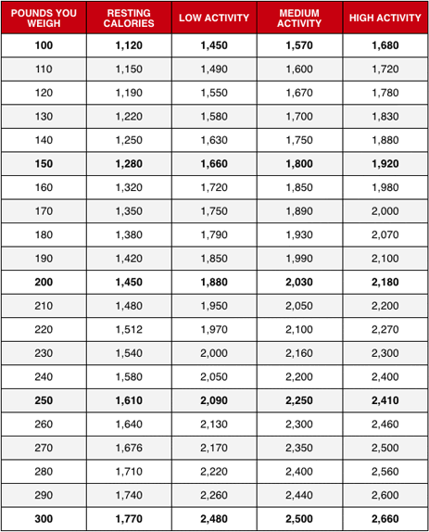

Resting calories is exactly what it sounds like. Calories needed to sustain your normal bodily functions, such as breathing, heart beating, eyes blinking, etc. If you happen to be ill, the caloric intake would be more, to help stave off infection.

You would be “Low Activity” if you have a desk job, and don't move around much or exercise. “Medium Activity” would be a person who, even with a desk job, goes out and exercises a few times a week. The “High Activity” would be someone who has a strenuous job, is a sports enthusiast and loves to exercise, (like we probably all should.)

The key here is, to take in less calories than we need in a given day, and use up the calories stored as fat on our bodies. With the green tea, this magnifies because our metabolism is higher, so we will burn it more quickly.

Now...let's get down and dirty and see what we are supposed to weigh, according to the healthy heart people.

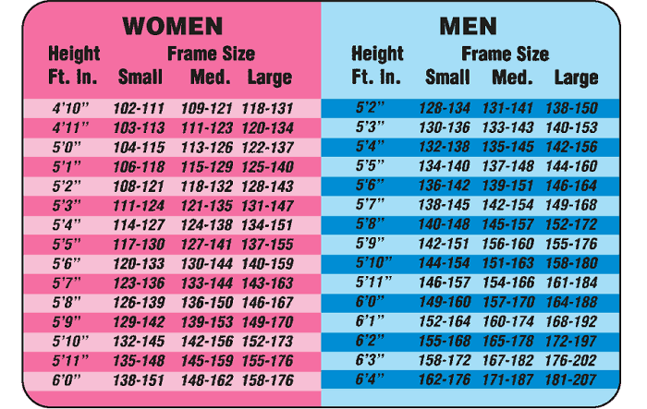

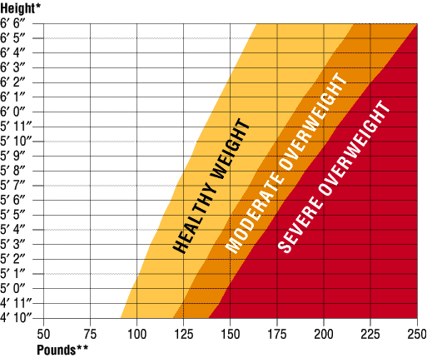

I could have made this guide much longer, but it was not necessary. My methods worked for me, and I believe they will work for you. I have made it short, and affordable so that everyone can buy it.

This is not brain surgery, although the weight loss guru's may make you think it is. That is their way of doing it so they can hike the price up. I have given you all the information you need to lose weight...and to lose it quickly. I will make a confession, through the holidays I did gain 4 pounds...but I guess that is expected. I quickly shed those pounds in the next couple of days. I am now at 190 pounds, so that is 45 pounds in less than 3 months, and I feel healthier and more energetic than I have in years.

If an inactive guy like me can lose that much weight, sitting in front of a computer screen, just think how much you could lose by following the methods outlined, and are a bit more active than I am.

I'm rooting for you!

Paul McDonald

